'Youngest inventor' patents broom
A five-year-old boy is thought to be the UK's youngest person to patent an idea after inventing a labor-saving broom to help his father sweep leaves.
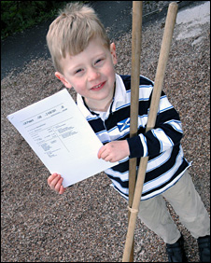
Sam is thought to be the youngest person in the UK to patent an idea
Sam Houghton, of Buxton, Derbyshire, was just three when he came up with a double-headed broom to collect large debris and fine dust simultaneously.
After passing the rigorous patenting process, his idea is now protected from anyone who might copy it.
His father, Mark, said there were no plans to market the broom.
Sam, who was inspired by animated inventors Wallace and Gromit and Archie the Inventor from TV series Balamory, said: "I saw my Daddy brushing up and made it. There are two brushes because one gets the big bits and one gets the little bits left behind.
I don't know if I want to be an inventor when I grow up but this was fun
Sam Houghton
"I don't know if I want to be an inventor when I grow up but this was fun."
Sam had been watching his father at work in the back yard, swapping between a large broom, for leaves and twigs, and a small one, for finer particles, when he came up with his idea.
Simple solution
Mr Houghton, who by chance is a patents lawyer, was so impressed he decided to help Sam apply for a patent.
He said: "It was such a simple solution that only a child could have come up with it.
"I was swapping from one broom to the other and he asked why. When I said it was to pick up the different leaves and twigs it must have got him thinking.
"He got a large elastic band from the shed and put it over the two brooms, holding them just the right way to use both together. He then called me and announced that had had made up an invention."
Insisting the broom itself was all Sam's idea, he said: "Putting the application together was just a matter of extracting the underlying principle and carefully describing that and Sam's specific way of using the invention."
"I do have experience of patents so I knew what to do next but I am convinced there are other young children who come up with ideas but never have the chance to get a patent for them."
The broom works with the coarser brush at the front to pick up larger objects and the finer brush at the back.
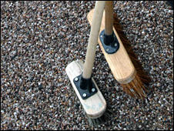
The Improved Broom has a coarse head in front and a finer brush behind
Mr Houghton, who spent about £200 getting the patent approved, said it was more about letting Sam have some fun than about marketing the broom.
He said: "Perhaps Sam will take it on when he is a bit older, after all a patent can last up to 20 years."
Sam's invention has been taken up by the UK-IPO, which is hoping to use it to encourage other youngsters to come up with inventions through an initiative called "Cracking Ideas".
While the scheme is aimed at older children, project manager Sally Long said Sam's invention had shown how the very young could often come up with the best ideas.
She said: "Sam has shown what a young mind can come up with.
"Patent applications do not always record ages but we have never come across anyone as young as Sam who has been successful in their application and believe he is the youngest yet."

